SIMATS ENGINEERING
ASSESSMENT TOOL 3

COURSE CODE: CSA1402 COURSE NAME: COMPILER DESIGN

COURSE OUTCOME COVERED

CO5: Develop code optimization and Code Generation using DAG representation with data flow analysis to produce optimized target code ( BL3)

Assessment Tool Weightage: 10%

QUESTIONS: 30 Total Marks:60

Annexure A

MOCK INTERVIEW

Code of Conduct:

I GAUTHAM B 192421318 (Name / Reg No) certify that this submission is my original work and that I have adhered to the guidelines specified for this assessment.
I understand that any violation of academic integrity rules will result in disciplinary action.

Signature of the student: GAUTHAM.B

Annexure A

MOCK INTERVIEW
QUESTIONS
- Why are regular expressions used in lexical analysis?
- How is a finite automaton related to a lexical analyzer?
- What is the difference between DFA and NFA?
- Why is DFA preferred for implementing lexical analyzers?
- How does a lexical analyzer handle the longest-match rule?
- What happens when two token patterns match the same lexeme?
- Why are comments usually removed during lexical analysis?
- How does a lexical analyzer distinguish between = and ==?
- What is lexical ambiguity? Give an example.
- How can a lexical analyzer detect an unterminated string?
- Why is grammar required in syntax analysis?
- What is the difference between derivation and parsing?
- What is leftmost derivation?
- What is rightmost derivation?
- What is the difference between leftmost and rightmost derivation?
- Why can a grammar generate multiple parse trees for the same input?
- How can ambiguity in an expression grammar be removed?
- Why is left recursion a problem for recursive-descent parsers?
- How can immediate left recursion be eliminated?
- Why is left factoring required in predictive parsing?

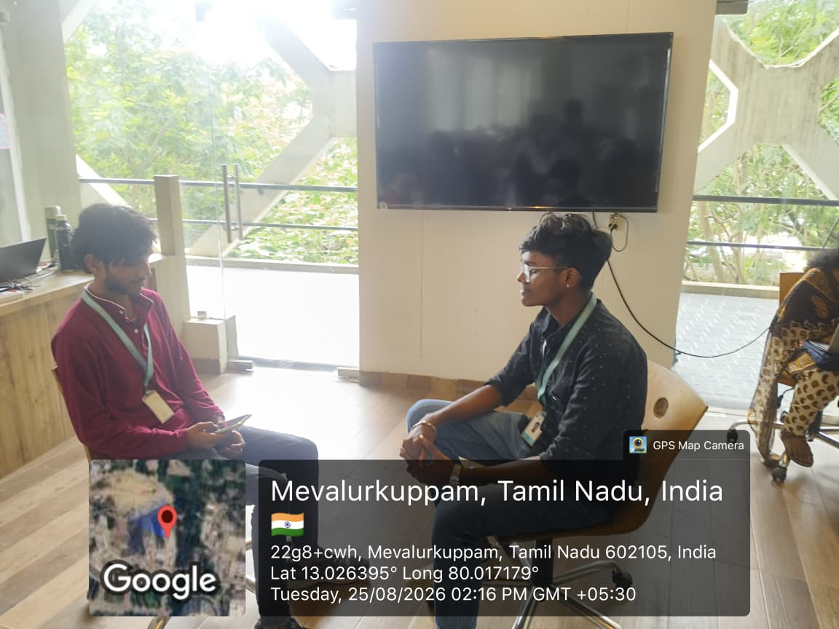

RUBRICS FOR CALCULATION:

Criteria | Weightage | Level 4 (Exemplary) | Level 3 (Proficient) | Level 2 (Developing) | Level 1 (Beginning)
Technical Knowledge | 25 | Demonstrates strong and accurate subject knowledge with in-depth understanding | Shows good knowledge with minor gaps | Basic knowledge with noticeable errors | Lacks fundamental technical knowledge
Problem Solving | 25 | Solves problems logically and applies concepts effectively in real scenarios | Applies concepts with moderate accuracy | Limited problem-solving ability; requires guidance | Unable to solve or apply concepts
Analytical Thinking | 15 | Analyzes questions critically and provides well-structured, logical answers | Provides reasonable analysis with some structure | Superficial or partially structured responses | No analytical thinking was demonstrated
Communication | 15 | Communicates clearly, confidently, and professionally with proper terminology | Communicates well with minor hesitation | Communication lacks clarity or confidence | Unable to communicate effectively
Confidence | 15 | Displays high confidence, positive attitude, and professional behavior throughout | Shows good confidence with minor issues | Low confidence; inconsistent behavior | Lacks confidence and professionalism
Response to Questions | 10 | Responds accurately, promptly, and elaborates with relevant examples | Responds correctly but with limited depth | Partial responses; needs prompting | Unable to respond appropriately

